**Supplementary Materials for “Rules of Co-occurring Mutations Characterize the Antigenic Evolution of Human Influenza A/H3N2, A/H1N1 and B Viruses”**

Haifen Chen, Xinrui Zhou, Jie Zheng and Chee-Keong Kwoh

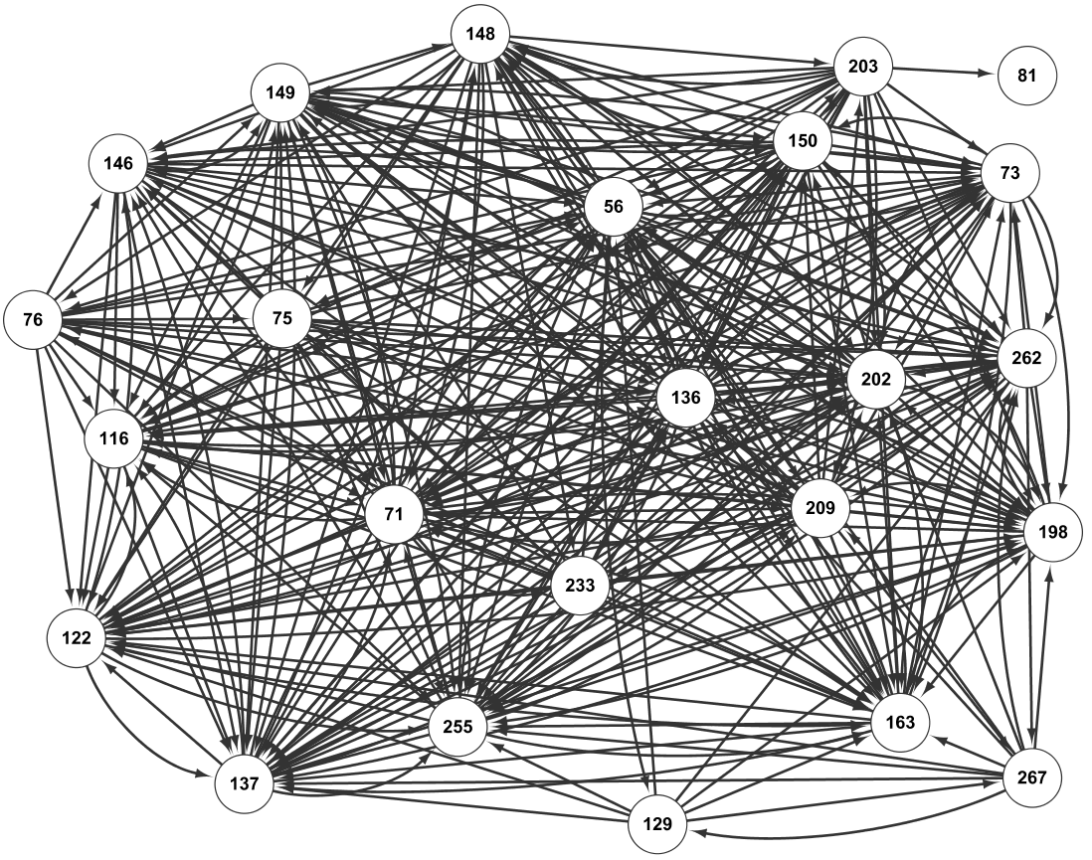

Figure S1. **Visualization of rules for B virus (based on all HA1 sequences of flu-B from 1975 to 2015)**. Note that the numbers inside the nodes denote the sites (numbering in the HA1 sequence), and the edges represent the association of the site mutations; similarly for the rest figures of ``Visualization of rules''.

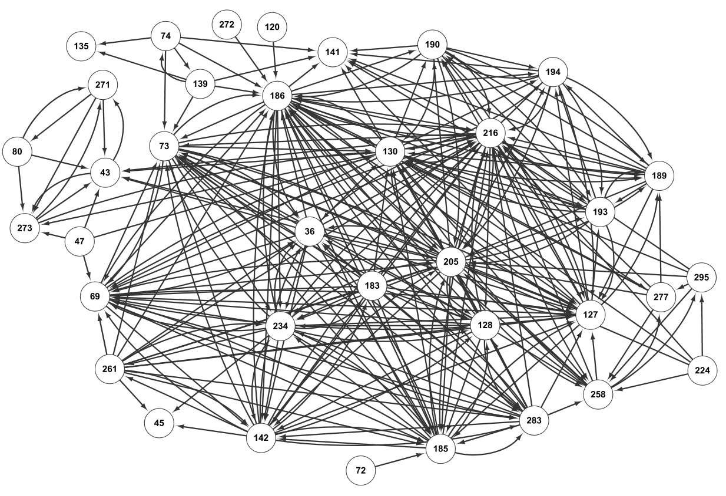

Figure S2. Visualization of rules for A/H1N1 virus (based on all HA1 sequences of H1N1 from 1976 to 2015)

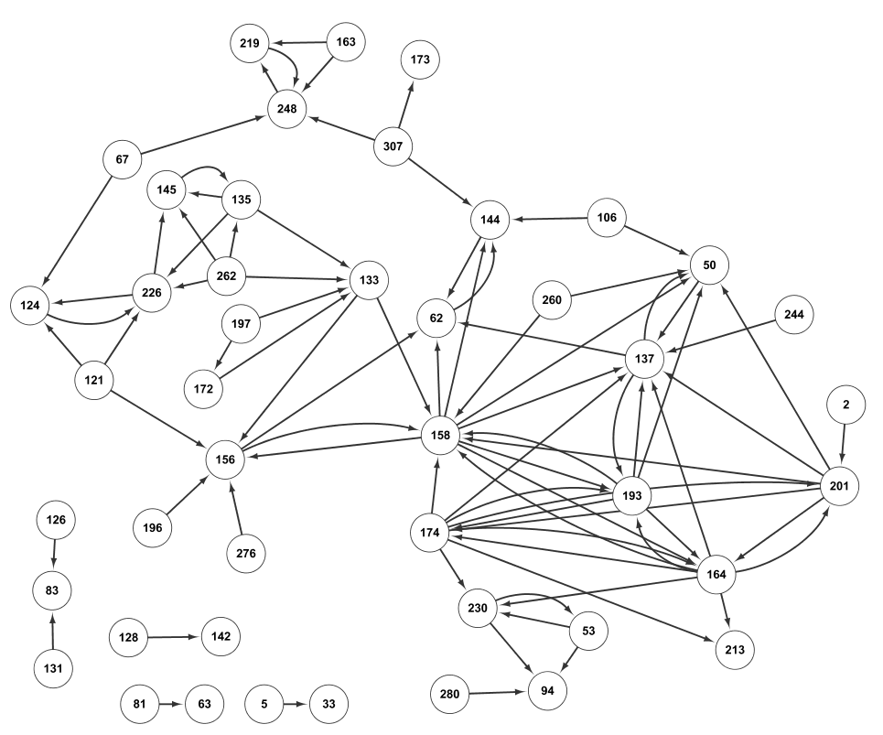

Figure S3. Visualization of rules for A/H3N2 virus (based on all HA1 sequences of H3N2 from 1968 to 2015).

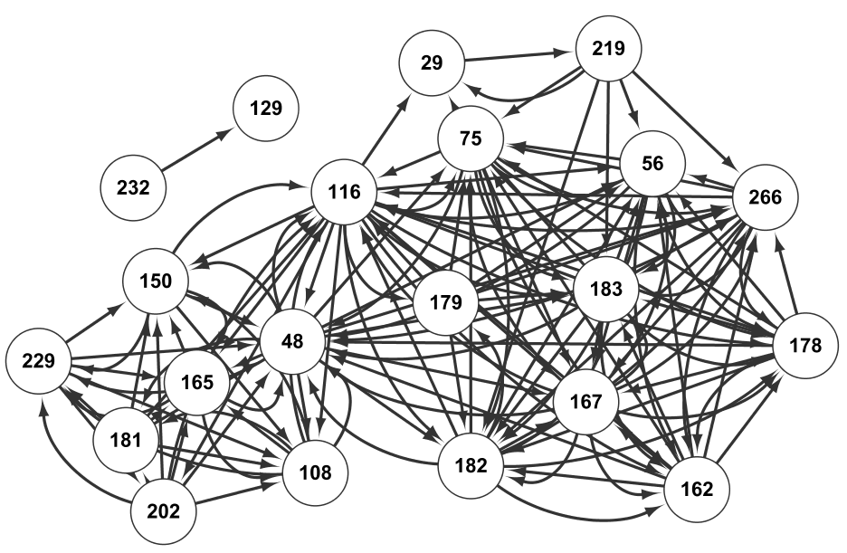

Figure S4. The network representing the rules of co-mutation sites in B viruses (Yamagata lineage).

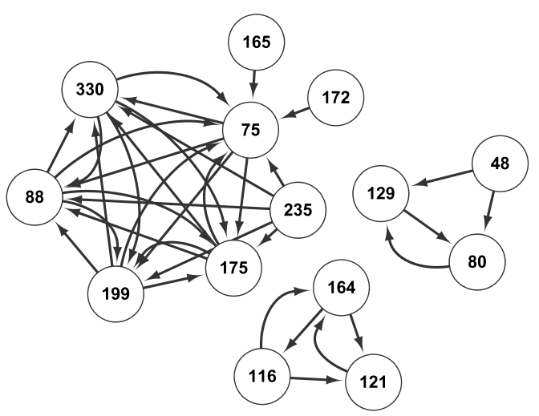

Figure S5. The network representing the rules of co-mutation sites in B viruses (Victoria lineage).

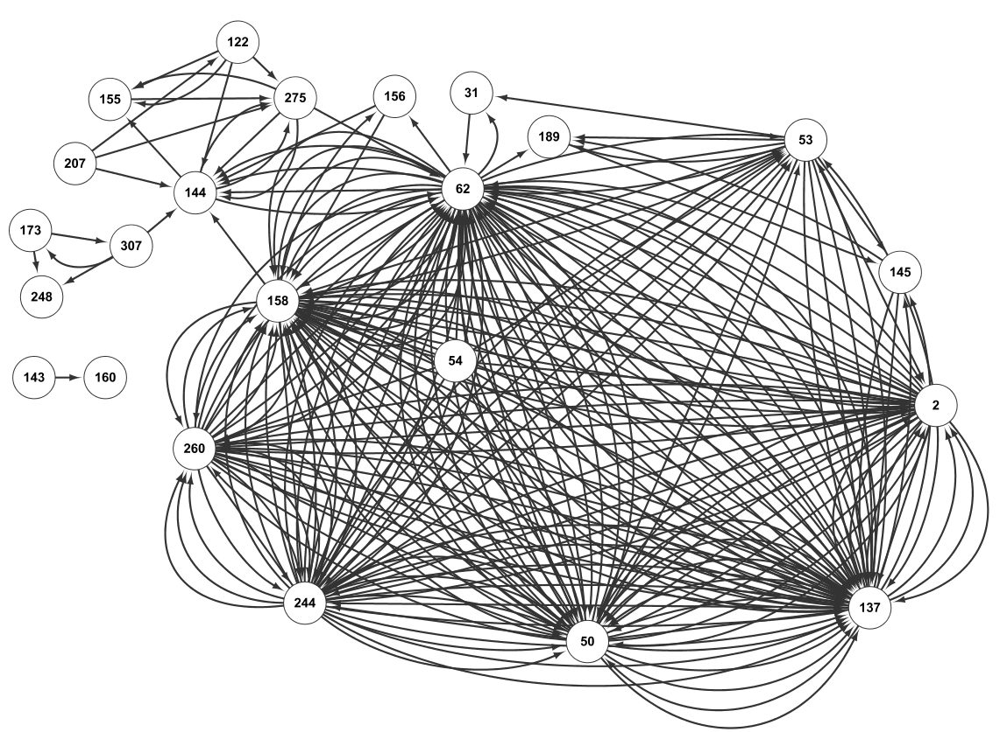

Figure S6. Network of co-mutation sites based on H3N2 sequences from 1968 to 2002 (same dataset as in Xia et al.)

Table S1. Comparison of site mutations prediction (for H3N2 in the year 2003) between our method and the approach in Xia et al.

